CONNECTED, LEVEL 3 2015, Fact or Fiction?  Catching a Space Duck  by Renata Hopkins  Overview  The “space duck” referred to in the title of this article is in fact a duck-shaped comet. It is this comet that scientists sent the Rosetta probe and its lander, Philae, to examine. The article describes how the mission was conceived and developed and the bumpy landing that eventuated. That landing might have been a disaster but has proved to be of great benefit, generating even more data than was originally anticipated.  A Google Slides version of this article is available at www.connected.tki.org.nz. This text also has additional digital content, which is available online at www.connected.tki.org.nz. |  |  | 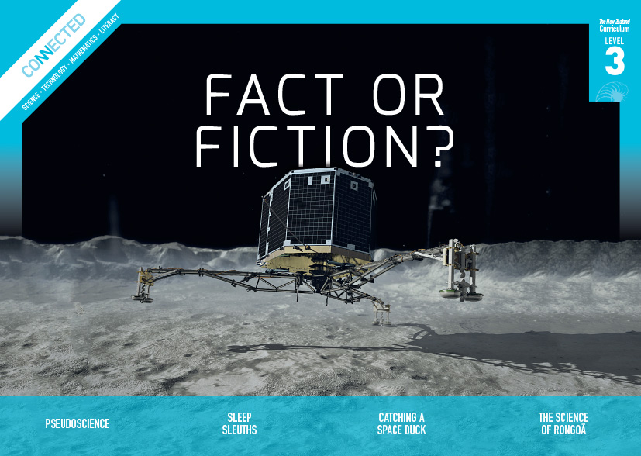  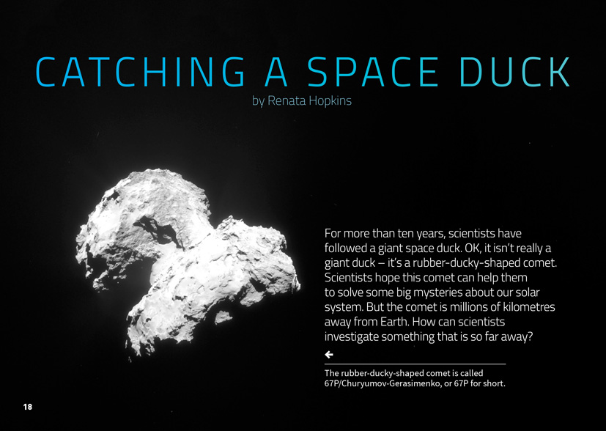
Science capability: Critique evidence |  | Text characteristics

Science knowledge is based on data derived from direct or indirect observations of the natural physical world. An inference is a conclusion drawn from those observations; it is the meaning you make from the observations. Understanding the difference between an observation and an inference is an important step towards being scientifically literate.  Being ready, willing, and able to critique evidence is also an important step towards being scientifically literate. Students must be able to assess the quality and reliability of both the observations (data) and the inferences made from those observations. In order to know what sorts of questions to ask to evaluate the trustworthiness of data, students need both methodological knowledge (how data is generated and collected) and statistical knowledge (how data is collated and analysed).  For more information about the “Critique evidence” science capability, go to http://scienceonline.tki.org.nz/Introducing-five-science-capabilities/Critique-evidence |  | - A clearly structured article with headings that signal the information in each section and help the reader to navigate the texts.  - Photographs and diagrams that clarify or extend the text and may require some interpretation.  - Many subject-specific and technical words with their meanings explained in the running text and in the glossary.

Curriculum context

SCIENCE
NATURE OF SCIENCE: Understanding about science  Achievement objectives  L3: Students will appreciate that science is a way of explaining the world and that science knowledge changes over time.  Students will identify ways in which scientists work together and provide evidence to support their ideas. |  | PLANET EARTH AND BEYOND: Astronomical systems  Achievement objective  L3: Students will investigate the components of the solar system, developing an appreciation of the distances between them. |  | Key Nature of Science ideas  Scientists:  - evaluate the trustworthiness of data by asking questions about investigations carried out by others  - undertake more than one trial to provide sufficient evidence to support a conclusion  - replicate investigations to critique the evidence or data provided by other scientists  - check that there are enough samples to reliably establish a conclusion  - look carefully at the way data has been collected when they consider investigations done by others.  Key science ideas  - The development of new kinds of technology has helped us to clarify and extend our theories about the universe.  - Scientists can test some of their theories about the universe by observing from Earth and by sending probes into space.

ENGLISH

READING  Ideas  Students will show a developing understanding of ideas within, across, and beyond texts. |  | INDICATORS  - Uses their personal experience and world and literacy knowledge confidently to make meaning from texts.  - Makes meaning of increasingly complex texts by identifying main and subsidiary ideas in them.  - Starts to make connections by thinking about underlying ideas in and between texts.  - Makes and supports inferences from texts with increasing independence. |  | THE LITERACY LEARNING PROGRESSIONS  The literacy knowledge and skills that students need to draw on by the end of year 6 are described in The Literacy Learning Progressions.

Critiquing evidence

The science capability “Critique evidence” is about students evaluating the quality of the data supporting a scientific claim or idea (http://scienceonline.tki.org.nz/Introducing-five-science-capabilities/Critique-evidence).
Scientists use empirical evidence to develop theories about how the world works.
- Empirical evidence is data gathered from observations, experiments, and investigations.
- Scientific claims are only as dependable as the evidence on which they are based.
- Scientists design their investigations carefully to ensure the data they gather is both reliable and valid. Valid data is data that measures what it is supposed to measure – it answers the research question. Reliable data is dependable and consistent. Replicating the experiment and getting the same results makes us more confident that the data is reliable.
- To gather high-quality evidence that is reliable and valid, scientists measure accurately, keep conditions the same or control variables that might influence measurements or observations, repeat tests or investigations many times, investigate multiple examples, and/or use statistical sampling techniques to make their observations or data as representative and accurate as they can.
Students should be critiquing and evaluating the quality of data gathered from their own investigations by:
- engaging in a range of investigation types, exploring, comparing, classifying, identifying, seeking patterns, using models, making things to test ideas, and investigating systems so that they learn different ways to gather different types of data
- identifying ways to make the data they collect in their own investigations as accurate and reliable as possible
- suggesting and developing ways to control conditions or variables or keep things fair, repeating observations or measurements or tests, and developing appropriate sampling methods
- applying their developing understanding of statistics and probability (sampling, variability, and the exploration of relationships in multivariate data) when making decisions about sample size and repetitions, and when working with their data.
Students should also be encouraged to look for, consider, and critique methods and data underpinning scientific claims made by others. This includes critically examining the appropriateness of methods and the quality of evidence used to develop scientific claims in the media and other sources.
Teachers can:
- help students to be more critical consumers of science information by being explicitly critical themselves
- support students to identify correlations as evidence of a potential relationship, but not necessarily cause and effect
- ask questions such as:
  - Would this always happen?
  - How sure are you of your measurements?
  - How many times should you repeat these tests/measurements?
  - Is this a fair result?
  - What may have influenced the data?
  - Was there a big enough sample?
  - Does the data match the claim?
  - How much variation is there in your results? Why might that be?
- support students to evaluate how data is presented; for example, if data is presented graphically, is this done appropriately or is it misleading? (This draws on another science capability, Interpret representations.)
- support students to apply their understanding of statistics and probability when considering claims, evidence, and data.
- establish a science classroom culture by:
  - modelling and encouraging a critical stance
  - encouraging students to consider the quality and interpretation of data underpinning scientific claims
  - using media headlines to introduce learning conversations and demonstrate the relevance of critiquing evidence to everyday life.
A range of questions and activities designed to get students to critique evidence is available on the Science Online website: http://scienceonline.tki.org.nz/Introducing-five-science-capabilities/Critique-evidence

Meeting the literacy challenges

The technical information along with the academic and subject-specific vocabulary provide the main literacy demands in this text. The following strategies will support students to understand, respond to, and think critically about the information and ideas in the text. You may wish to use shared or guided reading, or a mixture of both approaches, depending on the reading expertise of your students or on the background knowledge they bring to the text.
After reading the text, support students to explore the activities outlined in the following pages.

TEACHER resources

Want to know more about instructional strategies? Go to:
- http://literacyonline.tki.org.nz/Literacy-Online/Teacher-needs/Reviewed-resources/Reading/Comprehension/ELP-years-5-8
- “Engaging Learners with Texts” (chapter 5) from Effective Literacy Practice in Years 5 to 8 (Ministry of Education, 2006).
Want to know more about what literacy skills and knowledge your students need? Go to:
- http://literacyonline.tki.org.nz/Literacy-Online/Student-needs/National-Standards-Reading-and-Writing
- http://www.literacyprogressions.tki.org.nz/
“Working with Comprehension Strategies” (chapter 5) from Teaching Reading Comprehension (Davis, 2007) gives comprehensive guidance for explicit strategy instruction in years 4–8.
Teaching Reading Comprehension Strategies: A Practical Classroom Guide (Cameron, 2009) provides information, resources, and tools for comprehension strategy instruction.

INSTRUCTIONAL STRATEGIES

FINDING THE MAIN IDEA(S)
Introduce the text and provide a brief overview of its main purpose.
PROMPT the students to think about the title of this article.
How does the title help you to think about what the text is about?
What prior knowledge and connections have you made?
What questions could you ask about this title?
Have the students PREVIEW the text, reading the headings and looking briefly at the images.
How do the headings and photos provide further information about the content and focus of the text?
Does it bring to mind any other prior knowledge?
What questions does it raise for you?
The text headed “Dirty snowballs” requires the students to visualise the way comets orbit the Sun in two parts of the solar system and how they sometimes change direction in response to the impact of gravity from another large body. To check their understanding, have each student quickly sketch a cartoon to show this happening. Get them to check each other’s cartoons, with the focus not on the artistry but the concept. Alternatively, you could get three students to role-play this for the rest of the class, taking on the role of the Sun, a comet, and a passing star.
When reading the breakout text on the Rosetta Stone, CHECK that the students understand how the Rosetta Stone and Philae Obelisk became the “keys to understanding” the Egyptian hieroglyphs. EXPLAIN that the term “key” is used literally, because they provided a code for deciphering the hieroglyphs. Help the students to understand the switch to the more metaphorical use of the term for how Rosetta and Philae may help unlock the secrets of the solar system.
After the reading, ASK QUESTIONS to help the students IDENTIFY the main ideas.
What does the author tell us about why scientists want to know about comets?
How will scientists collect data from the comet?
What does this article tell us about the way scientists work?
Are there other questions that you think the author addressed?
Have the students RECORD a written response to each of these questions, supporting it with evidence from both the text and the images.

INTERPRETING THE PHOTOGRAPHS AND DIAGRAMS TO CLARIFY THE TEXT
TELL the students that the photos and diagrams require careful examination and clarification in order to gain a complete understanding of the text.
MODEL your own approach to interpreting the photograph on page 18.
When I see a photograph or a diagram for the first time, I find myself guessing what it is that I am looking at and why it is important enough to be in this article. All this first photograph shows me is a big rock – that could be pretty boring! But the first paragraph tells me that the photograph must be of the comet. That surprises me – the few times I’ve seen pictures of comets, they looked bright and fiery!
The second thing I do is read the caption. This confirms that this is the comet and it tells me its name – 67P/Churyumov-Gerasimenko. That’s a mouthful! No wondered they shortened it to 67P.
The next thing I do is look back at the photograph to see what else I can learn from it. The text says that it is shaped like a giant rubber duck. I’m not sure that I agree. Is this the head? And is this the body? What do you think? I notice that there are lots of holes. I wonder what has caused them. It seems bleak and lifeless.
I think that it is amazing that we can look at a photograph of an object that is so far away, but I also wonder what is so interesting about this big rock. That is a question I will have in my mind as we read the rest of this article.
As the students read, encourage them to take time to examine each of the images and talk with a partner about what it shows, why it was chosen for the article, and the ideas and questions it raises for them. PROMPT them to follow your example and:
Predict what the photograph or diagram might show
Read the caption and any labels to confirm their predictions
Make connections between what is in the image and what is in the text
Ask questions about what they are looking at and what makes it significant
Look at the details and infer what they may mean.

DEALING WITH TECHNICAL AND SUBJECT-SPECIFIC VOCABULARY
EXPLAIN to the students that this text uses a lot of words that are specific to the topic and that some of them are quite difficult. Part of learning to think and act like a scientist is learning the language a scientist uses! Point out that the meanings of some of the words are explained in the glossary and that the photographs show what some of the items actually look like. As the students read, have them record the words that are new to them. Afterwards, create a bank of the words that they need to know to talk about Rosetta and Philae. The following graphic organiser is a template that you and the students could use to present these words with contextual information.
Word
Definition
Picture
Synonym
Sentence

RESPONDING TO THE READING
Have the students write a narrative from the perspective of Philae, describing your adventures on 67P. Using information from the text, explain the voyage, the bounce, the final landing, and what is going on around you.
What is the environment like?
What has happened since you landed?
What do you hope to find out?
The students could create a diagram or model of the Rosetta probe using information from the text and from further online research. Have them label the parts and explain what they are used for.
The students could investigate Egyptian hieroglyphs and explore how they have helped to give access to information about ancient Egyptian history – a period that lasted for over three thousand years.

Key science ideas
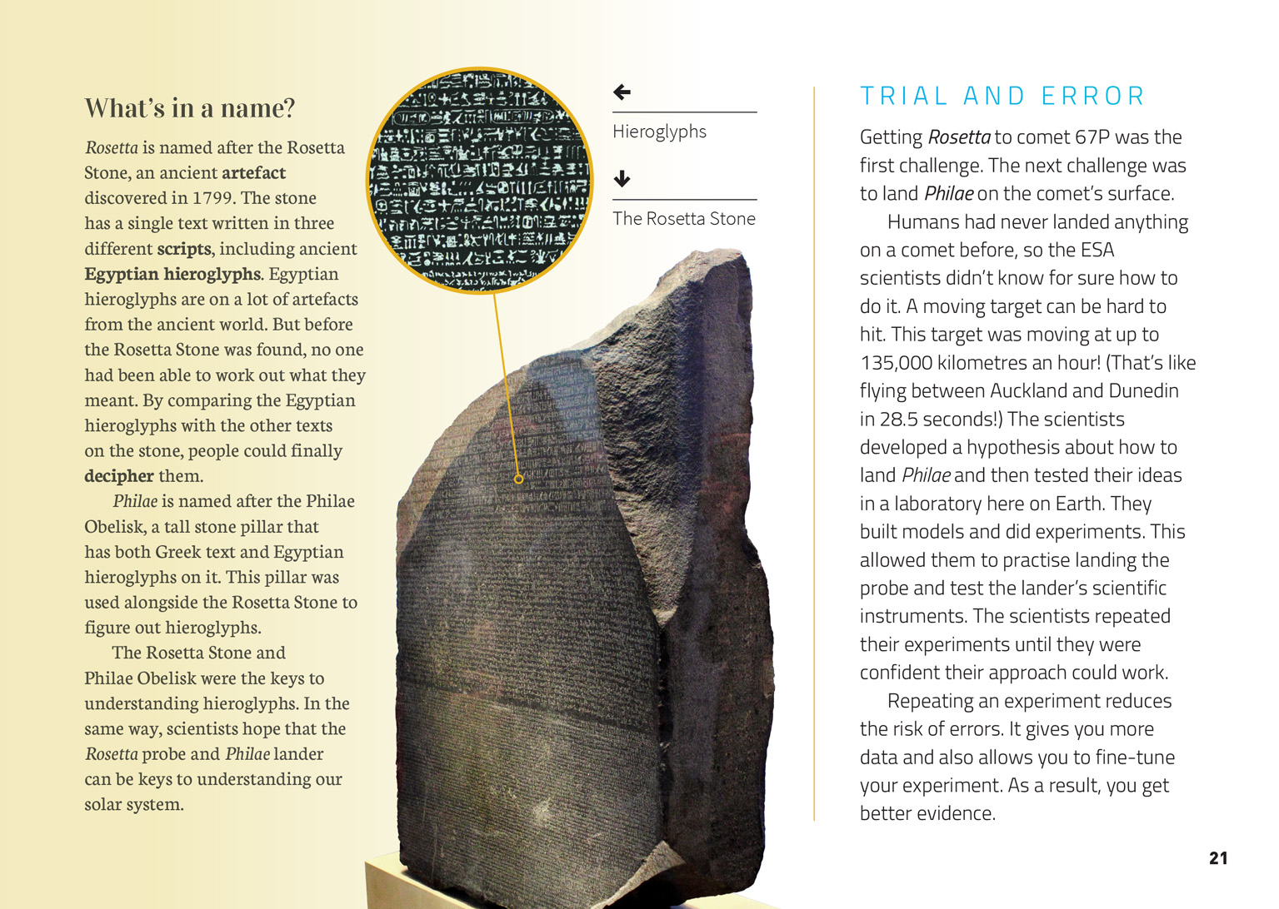 | Scientists repeat tests or investigations many times to make their data as accurate as they can.  Scientists use models to test ideas so they learn different ways to gather data.  Scientists design their investigations to make sure the data they gather is reliable.

Learning activities
The following activities and suggestions are designed as a guide for supporting students to explore and develop understandings about the science capability “Critique evidence”. Some activities focus directly on the science capability. Other activities extend student content knowledge across the learning areas. You are encouraged to adapt these activities to support your students’ learning needs.

exploring the science

Activity 1: Understanding the Rosetta mission
The story of Rosetta and Philae is an intriguing one that is likely to inspire considerable interest. There are many directions in which to take this learning, but a good first step would be to show the students one of the videos listed in the resource links. Depending upon your students’ level of interest and prior knowledge you could select one of the animated videos from the European Space Agency or one of the lengthier ones that provide more of the technical detail.
Help the students develop a sense of the immensity of the solar system by having them create a scale model, as described in the Science Learning Hub activity “Shrink the Solar System” (http://sciencelearn.org.nz/Contexts/Space-Revealed/Teaching-and-Learning-Approaches/Shrink-the-Solar-System). This activity involves the use of a range of measurements, from millimetres to light years, and will help the students develop the understanding that measurement is an important part of science.
Look again at the information in the article about the speed at which comet 67P was moving. To get a sense of this, have the students look at the distance between Auckland and Dunedin and then use a stopwatch to get a ‘feel’ of how long 28.5 seconds is. The students could then use tennis balls to try to hit a moving target (a soccer ball being rolled by a classmate). Have them record their observations and what happens if the ball hits the moving target.
What happens to each ball?
How often do they bounce?
What is the direction of movement?
What does your model tell you about what can happen when two moving objects collide?
How many times did you have to repeat your experiment to get a reliable picture of the things that can happen?
The BBC item “Rosetta Mission: Can You Land on a Comet?” provides information on the comet, lander, and mission. It includes a brief video clip highlighting the difficulty of the landing and an interactive game that further reinforces this concept (www.bbc.com/news/science-environment-29746430).
By now the students will have a concept of the size of the task faced by the ESA’s scientists and the importance of testing and retesting to fine-tune their experiments and reduce the risk of errors. In the article, they have read that the lander’s first bounce took two hours, due to the weakness of the comet’s gravity. Forces is a book in the Figure It Out series that you can use to support the students to explore concepts about gravity, force, mass, and friction.
In “Introducing Forces”, they learn about mass, force, gravity, and weight and explore constants and variables
In “Rocket Balloon”, they make rocket balloons and then conduct fair trials as they explore relationships between pressure, mass, angle, and speed
In “Flying High,” they make flying foxes, exploring how different variables affect time and speed and checking what makes a trial a fair trial.
Following this learning, take the students back into the design of rockets that are sent into space. The Science Learning Hub has a large bank of resources on rockets that includes the work of New Zealanders who are involved in designing such rockets. Connect this to a discussion of the considerations underpinning the design of Rosetta and Philae.
What do you know about how Philae was powered? What are the benefits and limitations of this?
How big was Philae? How did this affect what could be carried?
What do you think the scientists thought about in deciding upon the scientific instruments Philae carried? Why was it so important to test them?
Following this discussion, have the students work in groups to research online what has already been learned from the mission. Note that some of the early data indicates that the comet is capable of sustaining organic life and there is criticism that Rosetta and Philae are not equipped to search for direct evidence of life. This could lead to further thinking about the difficulty of planning a mission so far ahead and of prioritising what it is able to look for.
What do you think scientists might hope to learn from the Rosetta mission?
What have they found out already?
What are some new questions that you think this raises?
How valuable is this research? Do the benefits justify the enormous cost?
Extension
Use “Timeline – Brief history of rockets” on the Science Learning Hub to highlight the way technological change has accelerated over the twentieth and early twenty-first centuries (http://sciencelearn.org.nz/Contexts/Rockets/
Timeline). Students will likely know about the New Horizons mission to Pluto and the extraordinary images that are being sent back. Discuss the impact this rapid change has on the lives of ordinary citizens.
What do you know about how learning from space exploration has already affected people on Earth?
What do you think are the possible consequences of this expansion of knowledge?
Using what they have learned and the ideas they are thinking about, have the students write science fiction stories set in a plausible future where space travel is common.

Activity 2: Investigating comets
The students may be interested in exploring comets further. Record their questions and use them to co-construct an investigation. These are some suggestions:
If the students are interested in finding out about some of the comets astronomers are currently studying, they could visit Live Comet Data (www.livecometdata.com). They could record when the comets have been sighted and when they are predicted to next appear.
The NASA Rosetta – Education site has a range of student activities on the theme of comets (http://rosetta.jpl.nasa.gov/education). They include “Comet on a Stick”, which has students designing and building a model of a comet while learning about the basic characteristics of a comet and replicating the experience of scientific discovery.
The European Space Agency’s site has a new section of teaching resources, as well as a growing selection of resources specifically for children. The latter includes animated videos.
Experiments involving making comets out of dry ice are fun, but need to be conducted with care. The activity “Dry Ice Comet” (www.lpi.usra.edu/education/explore/comets/activity2.shtml) is intended to illustrate how the length and direction of a comet’s tail vary in relationship to the comet's location relative to our Sun. It also helps the students gain a better understanding of the composition of comets.
If possible, visit a local planetarium or make contact with a member of your nearest astronomical society to give the students the opportunity to look at a comet through a telescope. Have them prepare for their visit with questions they hope to answer.
Students may be interested in the cultural meanings of comets. They could conduct research online. Local kaumātua may have knowledge to share about how Māori viewed comets in pre-European times.
Extension
Keen students could maintain a watching brief on the data coming from both the Rosetta and New Horizons missions. They could post updates on the class blog.

RESOURCE LINKS

European Space Agency
“CometWatch – NavCam images of 67P taken by Rosetta’s navigation camera” http://sci.esa.int/rosetta/54523-cometwatch-navcam-images
“Measuring comet 67P/C-G” http://rosetta.jpl.nasa.gov/news/measuring-comet-67p/c-g
“Once upon a time … Preparing for comet landing” http://www.esa.int/spaceinvideos/Videos/2014/11/Once_upon_a_time_preparing_for_comet_landing
“Once upon a time…Comet landing” www.esa.int/spaceinvideos/Videos/2015/03/Once_upon_a_time_Comet_landing
“Rosetta’s lander Philae wakes up from hibernation” www.esa.int/Our_Activities/Space_Science/Rosetta/Rosetta_s_lander_Philae_wakes_up_from_hibernation
Rosetta, www.esa.int/Our_Activities/Space_Science/Rosetta
“Rosetta update” (26 May 2015) https://m.youtube.com/watch?v=nQ9ivd7wv30
Teach with Rosetta, http://www.esa.int/Education/Teach_with_Rosetta

NASA
“Comets in Ancient Cultures” from Deep Impact. http://deepimpact.umd.edu/science/comets-cultures.html
“Rosetta” from NASA Jet Propulsion Lab http://rosetta.jpl.nasa.gov/
“Rosetta” from NASA http://www.nasa.gov/rosetta/#.VH0wetKUd14
“Measuring comet 67P/C-G” from NASA Jet Propulsion Lab http://rosetta.jpl.nasa.gov/news/measuring-comet-67p/c-g
See especially the “Rosetta – Education” page, http://rosetta.jpl.nasa.gov/education

Science Learning Hub
“Becoming a rocket engineer” http://sciencelearn.org.nz/Contexts/Rockets/Sci-Media/Video/Becoming-a-rocket-engineer
“Comets” http://sciencelearn.org.nz/Contexts/Satellites/Looking-Closer/Comets
“Rockets” http://sciencelearn.org.nz/Contexts/Rockets/NZ-Research/Rockets
“Student Activity – Shrink the Solar System” http://sciencelearn.org.nz/Contexts/Space-Revealed/Teaching-and-Learning-Approaches/Shrink-the-Solar-System
“Timeline – Brief history of rockets” http://sciencelearn.org.nz/Contexts/Rockets/Timeline
“To catch a comet” http://sciencelearn.org.nz/Contexts/Satellites/Looking-Closer/To-catch-a-comet-the-Rosetta-Mission

Other sources
“Activity: Dry Ice Comet” from the Lunar and Planetary Institute. www.lpi.usra.edu/education/explore/comets/activity2.shtml
“Comet Breakthrough of the Year + People’s choice” from Science. www.sciencemag.org/content/346/6216/1442.full
“Comet Facts, Myths, and Legends” from Amazing Space. http://amazing-space.stsci.edu/resources/explorations/cometmyth/lesson/facts/index_nf.html
Forces, Figure It Out, levels 2+–3+, http://nzmaths.co.nz/figure-it-out-carousel-interface#c=14;p=0 (Including Introducing Forces, Rocket Balloon, Flying High)
Live Comet Data, http://www.livecometdata.com/
“Rosetta mission: Can you land on a comet?” from BBC News. www.bbc.com/news/science-environment-29746430
“Rosetta Spacecraft Mission” from Live Comet Data. www.livecometdata.com/rosetta-spacecraft-mission/
Twitter: Philae Lander https://twitter.com/Philae2014
Twitter: ESA Rosetta Mission https://twitter.com/ESA_Rosetta
“Updated: Rosetta mission successfully lands probe on comet – experts respond” from Science Media Centre. www.sciencemediacentre.co.nz/2014/11/13/rosetta-mission-successfully-lands-probe-on-comet/
“Your Guide to Pluto: Everything We’ve Learned from New Horizons So Far” from Earth and Space. http://space.io9.com/a-guide-to-pluto-everything-weve-learned-from-new-hori-1718799253
“Warwick Holmes: comets, probes and space” from Radio New Zealand National. www.radionz.co.nz/national/programmes/saturday/audio/20175246/warwick-holmes-comets,-probes-and-space (Warwick Holmes is a New Zealand scientist who worked on the Rosetta mission.)
“Water vapor on Rosetta’s target comet significantly different from that found on Earth” from Science Daily. www.sciencedaily.com/releases/2014/12/141210204716.htm

Google Slides version of “Catching a Space Duck” www.connected.tki.org.nz

